Change 1 : We have to say for which specific element we have to apply background.Like body , div, etc.
Example for understanding : Consider a scenario you are new to a place and don’t have mobile in your hand. Your mom said that to buy some grocery items.Your mom gave the list to u (what to do in our coding example)and she didn’t say where to buy means how you will buy it?(where to apply that effects in our coding example).
Change 2 : Add the closing cury braces }
Change 3 : Instead of giving backward slash(\) pls give forward slash(/).Because html / css files only accept forward slash.
Existing code: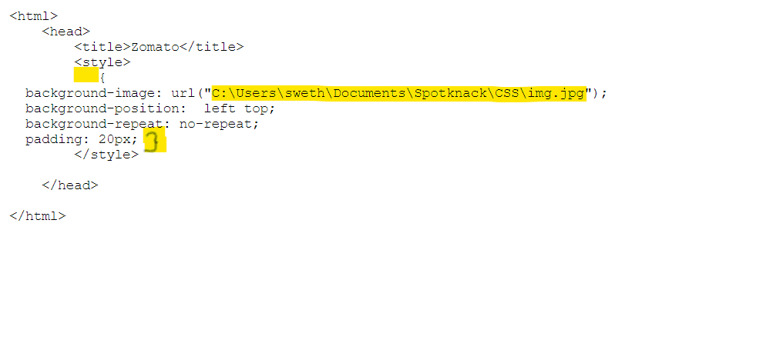Correct code :
<html>
<head>
<title>Zomato</title>
<style>
body {
background-image: url("C:/Users/LENOVO/Desktop/Developer.jpeg");
background-position: left top;
background-repeat: no-repeat;
padding: 25px;
}
</style>

</head>
<body>

</body>

</html>

